Smartphones to blame for slow service at restaurants
BY JEANETTE SETTEMBRE NEW YORK DAILY NEWS July 24, 2014
New York restaurant reviewed surveillance videos from 2004 and 2014 and discovered cell phones are slowing down service.
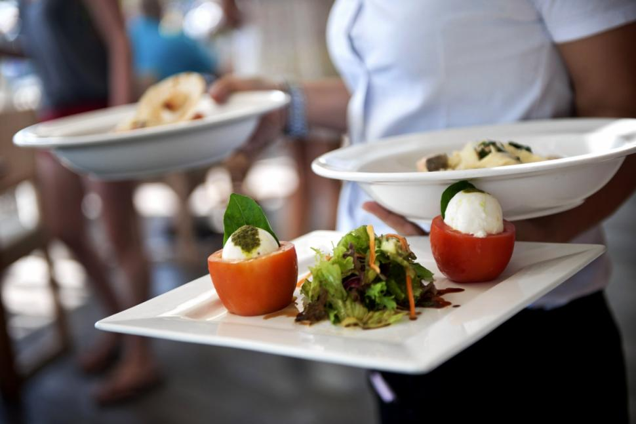
Here’s why your restaurant service stinks: You.
A famous New York restaurant — stung by increasing complaints about its allegedly slow waiters — discovered that the tardiness was actually the fault of the diners, not the staff.
“We added more staff and cut back on the menu items,” but the complaints continued, the manager of the unidentified restaurant said in his analysis, which was posted on Craigslist but later deleted.
It all started earlier this year, when the restaurant decided to go back to the drawing board to root out the problem.
“The number of customers we serve on a daily basis is almost the same today as it was 10 years ago, (but) the service just seems super slow even though we added more staff and cut back on the menu items,” the manager said.
Luckily, he had saved surveillance footage of the dining room from 2004 — then practically dropped his fork when he compared it to 2014.
The waitstaff hadn’t really changed its approach. The diners had:
- Instead of a 1 hour and five minute meal from water to check in the pre-smart phone age, Yelp-era eaters take 1 hour and 55 minutes — and cell phones are to blame.
- In 2004, three out of 45 customers requested to be seated in a different place. In 2014, 18 out of 45 did.
- In 2004, no one took pictures of his food. In 2014, more than half the diners did, wasting an average of three minutes.
- In 2004, 2 out of 45 customers sent items back. Ten years later, 9 out of 45 customers sent their food back for reheating — because of all that digital photography, the manager said.
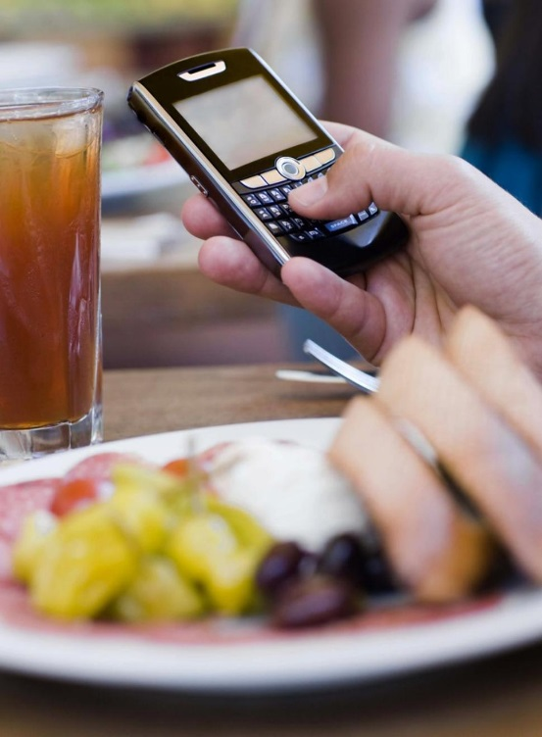
- In 2004, customers on average spent eight minutes before closing the menu to show they were ready to order. It’s longer today, thanks to cell phones, though the manager did not provide an actual amount of time.
- In 2004, after guests were done with the meal, the check is delivered — and the guests depart within five minutes. This year, it guests requested their checks 20 minutes later on average after they were done eating. Once the check was delivered, they took took 15 minutes longer to pay and leave.
- In 2004, no one asked the waiter to take a group photo. This year, 27 out of 45 customers did. And 14 of those requested the waiter retake the photo.
- It’s unclear what restaurant conducted the investigation, but plenty of restaurants are experiencing the cell hell of food paparazzi.

All that photography “takes away a little bit of my intellectual property too,” says Gilles Coujon of the famous French restaurant L’Auberge du Vieux Puits, adding that by the time customers finished photographing the dish, it often went cold.
Some restaurants even make customers surrender their smart phones during the meal while others, like Bucato in Los Angeles, have banned phones all together.

